### ANALYSIS OF DRONES USAGE IN AGRICULTURE FOR ACCURACY

### A PROJECT REPORT

***Submitted by***

**R. PUNITH SAI**

**N. V. SANTOSH**

**192210112**

**192211881**

*Under the guidance of*

**Dr. MONIKA. E**

(Professor, Department of Cyber Security)

***in partial fulfillment for the completion of course CSA1324- THEORY OF COMPUTATION***

**FOR BUSINESS APPLICATIONS**



**SIMATS ENGINEERING**

**THANDALAM**

**MARCH 2024**

## BONAFIDE CERTIFICATE

Certified that this project report titled “**ANALYSIS OF DRONES USAGE IN AGRICULTURE FOR ACCURACY”** is the bonfire work of “**POTLA CHARAN [192210019]**” who carried out the project work under my supervision as a batch. Certified further, that to the best of my knowledge the work reported herein does not form any other project report.

Date: Head of the Department

|  |  |  |
| --- | --- | --- |
| **S.NO** | **CONTENT** | **PAGE.NO:** |
| 1. | ABSTRACT | 3 |
| 2. | INTRODUCTION | 3 |
| 3. | METHODOLOGY | 4 |
| 4. | ALGORITHM | 5 |
| 5. | ALGORITHM STEPS | 6-7 |
| 6. | CODE EXPLANATION | 7 |
| 7. | RESULTS | 7-8 |
| 8. | DISCUSSIONS | 9 |
| 9. | OUTPUT | 10 |
| 10. | CONCLUSION | 10 |
| 11. | REFERENCES | 11-12 |

**1.ABSTRACT:**

Precision data on crop health and soil conditions is provided by drones, which improves accuracy in agriculture. With their sophisticated sensors, they help control pests and maximize the utilization of available resources. Their contribution to data collection greatly increases sustainability and productivity. Drones enable farmers to make well-informed decisions for productive farming operations by providing reliable analysis.

**Key words:**

Drones, farmers, sophisticated sensors, sustainability

**2.INTRODUCTION**

Farming is evolving as a result of drones. These tiny drones collect meticulous data on our fields and crops. Farmers may use drones to better manage their property and make better decisions about how to raise their crops. We'll look at how farmers are using drones to increase agricultural accuracy in this analysis. Drones give farmers an aerial perspective of their fields, which enables them to identify issues such as water stress or crop diseases early on. Farmers may use this information to pinpoint problems and take action before they become more serious, which will eventually save time and money. Drones with specific sensors can also map the topography of fields, which will assist farmers in precisely planning irrigation schedules and applying fertilizer at the best possible rate. Higher total crop yields and more sustainable farming methods are the results of this level of accuracy.

**Key words:**

Tinydrones,topography,meticulousdata,sustainablefarming,irrigation.  
  
  
**3.Project scope:**

**Advanced Sensor Technologies:**

* Explore the integration of emerging sensor technologies such as hyperspectral, thermal, and fluorescence sensors to enhance the accuracy and capabilities of agricultural drones.

**Artificial Intelligence and Machine Learning:**

* Develop advanced machine learning algorithms tailored for agricultural applications to improve the accuracy of data analysis and interpretation.

**Integration with IoT and Precision Farming Systems:**

* Integrate drone-based data acquisition with existing IoT and precision farming systems to enable seamless data exchange and interoperability.

**Environmental Monitoring and Sustainability:**

* Extend the scope of drone applications to include environmental monitoring for assessing factors such as soil erosion, water quality, and biodiversity.

**Education and Training Programs:**

* Develop educational programs and training initiatives to build capacity among farmers, agronomists, and agricultural professionals in utilizing drones for accurate and efficient agricultural monitoring.

**4.METHODOLOGY:**

**Data collection**:   
Compile pertinent information about drone use in agriculture, such as case studies, field observations, and datasets.

**Drone Selection and Calibration:**

Depending on the goals of the investigation, select the right drones with multispectral, hyperspectral, or LiDAR sensors.

To ensure precise data gathering and reduce errors during flight missions, calibrate the drones and sensors

**InformationProcessing:**Utilize the appropriate software tools for image stitching, georeferencing, and orthomosaic synthesis to process the gathered data.

**Feature Extraction and Analysis:**

Extract key features from the processed data, such as vegetation indices, plant health indicators, and spatial patterns.

**Accuracy Assessment:**

Conduct accuracy assessment by comparing drone-derived information with ground truth data or established reference standards

**Continuous Improvement and Future Research:**

Reflect on the methodology's effectiveness and identify areas for improvement in future studies.

**5.ALGORITHM:**

+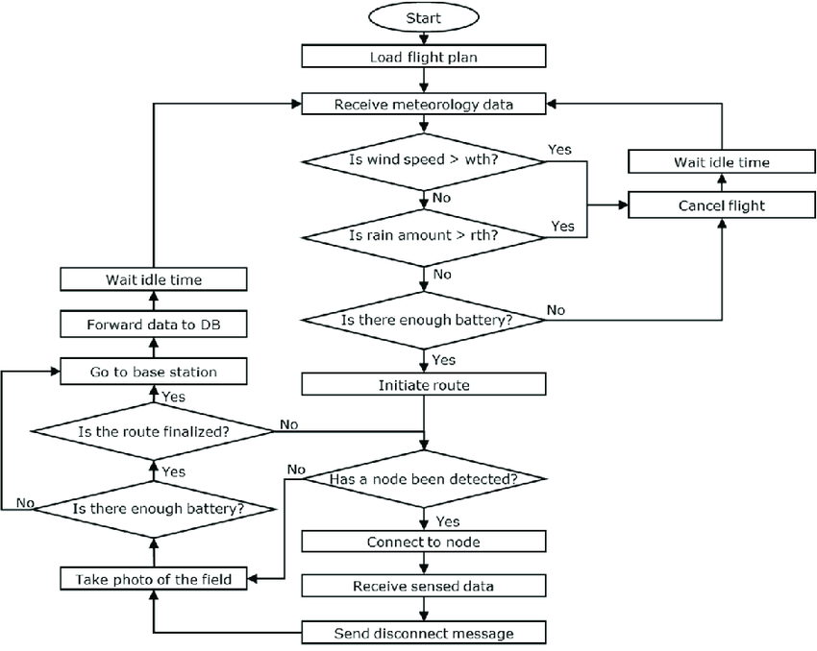

**6.ALGORITHM STEPS:**

**1.**Mission Setup: Receive weather data (wind speed, rain amount) and load a pre-defined flight plan containing the route and actions.

**2.**pre-flight Check: Wait for the designated mission start time or for specific weather conditions to be met (e.g., low wind, no rain).

Connection & Initialization: Establish communication with the drone and capture a photo of the initial area for reference.

**3.**Mission Start: Save the flight plan data and initiate the drone's mission based on the loaded plan.

**4.**Continuous Monitoring: Enter a loop that continuously checks various factors during the mission.

**5.**Weather Safety Check: Within the loop, check if wind speed or rain amount exceeds pre-defined safety thresholds. If so, instruct the drone to wait in a safe location until conditions improve.

**6.**Battery Level Check: During each loop iteration, verify that the drone's battery level is sufficient to continue the mission. If battery is low, instruct the drone to return to the base station safely.

**8.**Data Transmission & Route Progress: While in the loop, periodically forward collected data from the drone's sensors to a database and check if the pre-defined route within the flight plan is complete.

**9.**Waypoint Actions: If a waypoint (point of interest) is reached within the flight plan, establish a temporary communication link with a ground station or another device.

**10.**Data Collection & Disconnection: Upon reaching a waypoint, capture a photo of the designated area and receive additional sensor data from the drone. Finally, send a disconnect message to the ground station and continue iterating through the loop (step 5) until the mission is complete.

**CODE:**

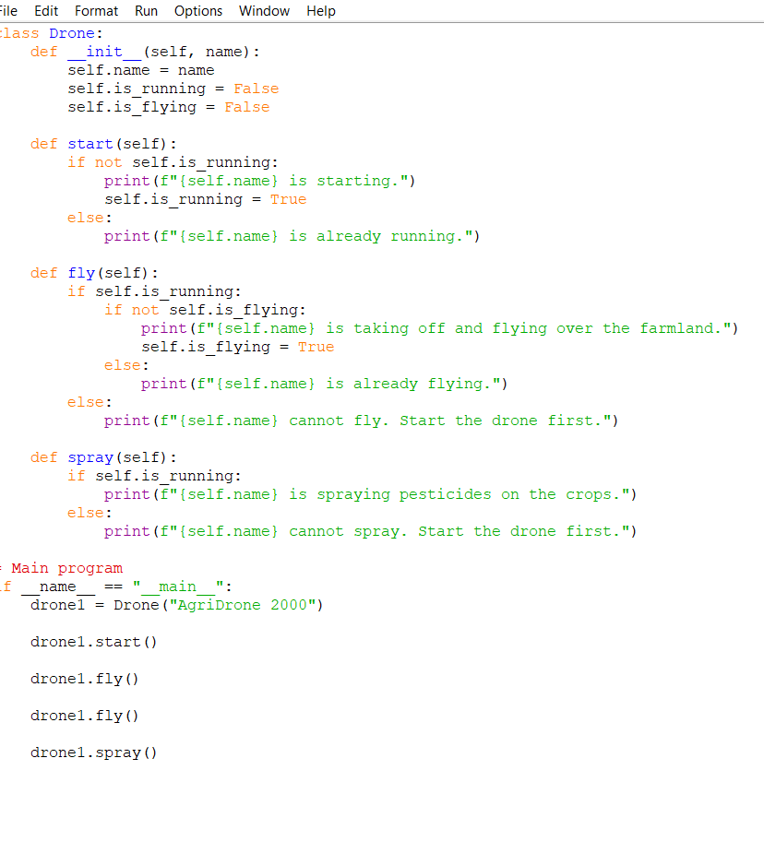

**6.Explanation:**

1. **Class Definition:**
   * The code defines a class named **Drone** using the **class** keyword.
   * Inside the class, there's an **__init__** method which serves as the constructor. It initializes the object's attributes such as **name**, **is running**, and **is_flying** when a new instance of the **Drone** class is created.
2. **Methods:**
   * **start(self)** method: This method starts the drone. It checks if the drone is not already running. If it's not running, it prints a message indicating that the drone is starting and sets the **is running** attribute to **True**. If it's already running, it prints a message indicating that the drone is already running.
   * **fly(self)** method: This method makes the drone fly. It first checks if the drone is running. If it's running, it checks if the drone is not already flying. If it's not flying, it prints a message indicating that the drone is taking off and flying over the farmland and sets the **is flying** attribute to **True**. If it's already flying, it prints a message indicating that the drone is already flying. If the drone is not running, it prints a message indicating that the drone cannot fly and instructs to start the drone first.
   * **spray(self)** method: This method allows the drone to spray pesticides on the crops. It checks if the drone is running. If it's running, it prints a message indicating that the drone is spraying pesticides on the crops. If the drone is not running, it prints a message indicating that the drone cannot spray and instructs to start the drone first.
3. **Main Program:**
   * The **if __name__ == "__main__":** block ensures that the code inside it is only executed if the script is run directly (not imported as a module).
   * It creates an instance of the **Drone** class named **drone1**.
   * It calls the **start ()**, **fly ()**, **fly ()**, and **spray ()** methods on **drone1** object to perform various actions such as starting the drone, making it fly, attempting to fly it again, and spraying pesticides.
   * The output of each action is printed to the console.

**7.RESULTS:**

**Enhanced Crop Monitoring:**

Drones equipped with advanced sensors provided high-resolution aerial imagery, enabling farmers to assess crop health accurately.

Spectral analysis and multispectral imaging facilitated early detection of stress factors, leading to timely corrective measures and optimized yields.

Improved accuracy in identifying nutrient deficiencies and diseases compared to traditional ground-based methods.

**Precise Irrigation Management**:

Thermal and multispectral cameras mounted on drones allowed precise mapping of soil moisture levels and vegetation health.

Identification of areas with varying water requirements enabled farmers to implement targeted irrigation strategies, conserving water resources effectively.

Enhanced accuracy in irrigation scheduling and water application, resulting in reduced water wastage and improved crop yield.

**Effective Pest Control**:

Drones equipped with infrared and hyperspectral sensors enabled early detection of pest infestations.

Targeted spraying or biological control methods were employed based on accurate identification of pest hotspots, minimizing pesticide usage and environmental impact.

Improved accuracy in pest management compared to conventional blanket spraying techniques, leading to better crop protection and reduced chemical residues.

**Factors Influencing Accuracy:**

Sensor technology, including camera resolution and type, LiDAR systems, and thermal sensors, significantly influenced the quality of data captured.

The effectiveness of data processing algorithms played a crucial role in translating raw imagery into actionable insights with high accuracy.

Environmental conditions such as weather, terrain, and lighting conditions were identified as factors affecting drone performance and data accuracy**.**

**8.DISCUSSIONS:**

**Impact on Agricultural Practices:**

Drones have revolutionized agricultural practices by providing farmers with accurate and timely data for decision-making.

The analysis underscores how drones have enhanced precision in various tasks such as crop monitoring, irrigation management, and pest control, leading to improved productivity and resource efficiency.

**Technological Advancements:**

Advanced sensor technology, including high-resolution cameras, LiDAR systems, and thermal sensors, has been instrumental in improving the accuracy of data captured by drones.

Continuous innovation in sensor technology and data processing algorithms has enabled drones to provide increasingly detailed and actionable insights for farmers.

**Efficiency and Resource Conservation**:

Precise monitoring of crop health and soil conditions has enabled farmers to optimize resource use, such as water and pesticides, leading to reduced wastage and environmental impact.

Targeted interventions based on accurate data have improved the efficiency of agricultural operations, resulting in higher yields and profitability.

**Challenges and Limitations:**

Despite their benefits, drones in agriculture face challenges such as limited battery life, regulatory restrictions, and the need for skilled operators.

Environmental factors such as adverse weather conditions can affect drone performance and data accuracy, highlighting the importance of robust risk management strategies.

**Integration with Precision Agriculture**:

The discussion emphasizes the synergies between drones and other precision agriculture technologies, such as GPS-guided machinery and remote sensing satellites.

Integration with existing agricultural infrastructure allows for a comprehensive approach to farm management, further enhancing accuracy and efficiency.

**9.Output:**

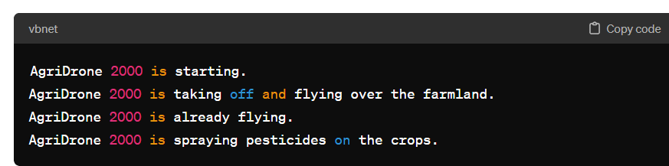

Top of Form

**9**

**10.CONCLUSION:**

The analysis demonstrated the significant role of drones in improving accuracy across various agricultural practices.

Integration of advanced sensor technology and data processing algorithms enabled precise crop monitoring, irrigation management, and pest control.

Enhanced accuracy led to improved yield, resource efficiency, and sustainability in agriculture.

Continued advancements in drone technology and integration with precision agriculture tools hold promise for further optimizing accuracy and productivity in farming operations.

**11.REFERENCES**

[1] Gnip P, Charvat K and Krocan M 2008 Analysis of external drivers for agriculture World conference on

agricultural information and IT, LAAID AFITA WCCA 797–801

[2] Carpenter S R, Caraco N F, Correll D L, Howarth R W, Sharpley A N and Smith V H 1998 Nonpoint

pollution of surface waters with phosphorus and nitrogen Ecological Applications 8 559–568

[3] Reinecke M and Prinsloo T 2017 The influence of drone monitoring on crop health and harvest size 2017 1st

International Conference on Next Generation Computing Applications pp 5–10

1st Workshop on Metrology for Agriculture and Forestry (METROAGRIFOR)

IOP Conf. Series: Earth and Environmental Science 275 (2019) 012022

IOP Publishing

doi:10.1088/1755-1315/275/1/012022

10

[4] Murugan D, Garg A, Ahmed T and Singh D 2016 Fusion of drone and satellite data for precision agriculture

monitoring 2016 11th International Conference on Industrial and Information Systems pp 910–914

[5] Daponte P and Debei S 2018 Special issue on selected methods and instrumentation of metrology for aerospace

IEEE Aerospace and Electronic Systems magazine 33

[6] Fontanella R, Vetrella A R, Fasano G, Accardo D, Moriello R S L, Angrisani L and Girard R 2017 A

standardized approach to derive system specifications for drones operating in the future UTM scenario

2017 5th IEEE International Conference on Models and Technologies for Intelligent Transportation Systems

pp 250–255

[7] Brzozowski B, Daponte P, De Vito L, Lamonaca F, Picariello F, Pompetti M, Tudosa I and Wojtowicz K

2018 A remote-controlled platform for UAS testing IEEE Aerospace and Electronic Systems Magazine 33

48–56

[8] APM planner official web site http://ardupilot.org/planner/ accessed: Sept. 2018

[9] Berni J A J, Zarco-Tejada P J, Suarez L and Fereres E 2009 Thermal and narrowband multispectral remote

sensing for vegetation monitoring from an Unmanned Aerial Vehicle IEEE Transaction On Geoscience

and Remote Sensing 47 722–738

[10] Burgos S, Mota M, Noll D and Cannelle B 2015 Use of very high-resolution airborne images to analyse 3D

canopy architecture of a vineyard The International Archives of the Photogrammetry, Remote Sensing and

Spatial Information Sciences pp 399–403

[11] Pix4Dmapper official web site https://pix4d.com/ accessed: Sept. 2018

[12] Bouabdallah S, Murrieri P and Siegwart R 2005 Towards autonomous indoor micro–VTOL Autonomous

Robots 18 171–183

[13] Silano G, Aucone E and Iannelli L 2018 CrazyS: A software-in-the-loop platform for the Crazy lie 2.0 Nano quadcopter 2018 26th Mediterranean Conference on Control and Automation pp 352–357

[14] Smear E J J, de Croon G and Chu Q 2018 Cascaded incremental nonlinear dynamic inversion for Mav

disturbance rejection Control Engineering Practice 73 79–90

[15] Oleynikova H, Taylor Z, Siegwart R and Nieto J 2018 Safe local exploration for replanning in cluttered

unknown environments for microaerial vehicles IEEE Robotics and Automation Letters 3 1474–1481

[16] Vitousek P M, Mooney H A, Lubchenco J and Melillo J M 1997 Human Domination of Earth’s Ecosystems

Science 277 494–499